Following topic will be used “devicereceive”

Make sure that broker should have retain functionality, the message sent from server side to system, the message should be retained on broker and should be able to clear retained messages when ACK/NACK is sent
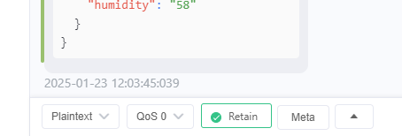

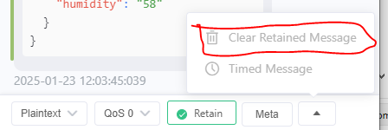

format setTimedate:epoch|timezone Reply:ACK/NACK

format setFuelMeasurement:zerospan|fullspan Reply:ACK/NACK

format setSoCnDCur:SOC|CurrentOffset Reply:ACK/NACK

format setAutoManualMode:(0 - Auto 1 - Manual) Reply:ACK/NACK

format setGenerator: (0 - GeneratorOff 1 - GeneratorOn) Reply:ACK/NACK

format getSoCnDCur Reply: SoC|CurrentOffset

format getSystemMode Reply: Auto/Manual 0 - Auto 1 - Manual

